Assignment 4 Part 1: Queries

User

User Query: *List the usernames in ascending order with user IDs between 2 and 5, lowest to greatest.*

SELECT user_id, user_name FROM users

WHERE user_id > 0002 AND user_id < 0005

ORDER BY user_name ASC;

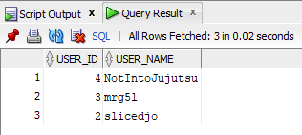

Admin

Admin Query: *List the admin usernames and their passwords that have an id number greater than two, lowest to greatest.*

SELECT admin_username, admin_password FROM admins

WHERE admin_id > 2  
 ORDER BY admin_id ASC;

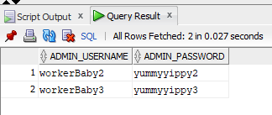

Item

Item Query: *List all the items with the same item name, sorted by greatest to least price*

SELECT item_name, item_buyPrice FROM items

WHERE item_name = ‘toiletPaper’

ORDER BY item_buyPrice DESC;

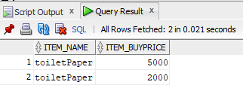

Auction

Auction Query: *List all unique items on auction by users between 0 and 9, by the item id from greatest to least.*

SELECT user_id, item_id FROM auctions

WHERE user_id > 0 AND user_id < 9  
 ORDER BY item_id DESC;

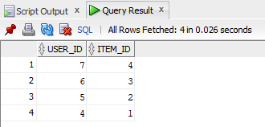

Finance

Finance Query: *List all finance numbers in descending order where user ID is greater than 2 with the corresponding expiration date and cvv*

SELECT finance_number, finance_expiry, finance_cvv FROM finance

WHERE user_id > 2

ORDER BY finance_number DESC;

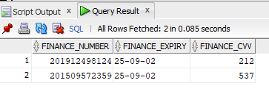

Shipping

Shipping Query: *List all auction recipients that have a tracking number between 0 and 90000 exclusive, from greatest to least*

SELECT shipping_reciever, shipping_tracking FROM shipping

WHERE shipping_tracking > 0 AND shipping_tracking < 90000  
 ORDER BY shipping_reciever DESC;

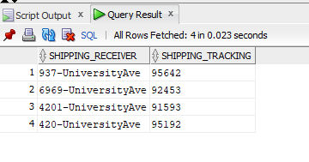

*List all unique buyers that have won an auction and are receiving an item, from least to greatest*

SELECT DISTINCT shipping_receiver FROM shipping

ORDER BY shipping_receiver ASC;

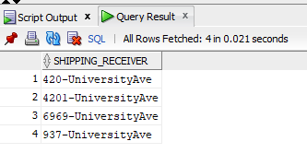

Bids

Bids Query: *List all top bids with the current highest bid with bids that are less than 5000$ and output them greatest to lowest by the value of the bid*

SELECT DISTINCT user_id, item_id FROM bids

WHERE bids_top < 5000

ORDER BY bids_top DESC;

